This test has two parts.
PART 1
Circle the correct letter (a, b, c or d), and answer the questions in the space provided.
- Which diagram of a beaker is the best one?
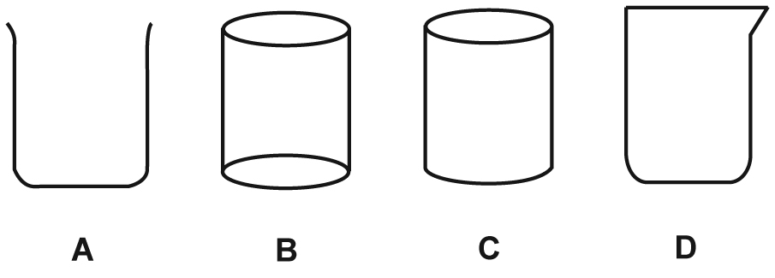
Give a reason for your answer.
__________________________________________________________________
__________________________________________________________________
(I 3.2)
2 If you accidentally spill some chemicals in your eyes, what should you do?
a wipe your eyes with a cloth
b tell someone to get the eyewash
c have a friend wipe your eyes
d wash your clothes under a tap
Give a reason for your answer.
__________________________________________________________________
__________________________________________________________________
(I 3.2)
3 A student had a 500 mL beaker, and wanted to heat 250 mL of water in it. What other equipment would they need?
a Bunsen burner, retort stand, wire mat, clamp and boss head
b tripod stand, Bunsen burner, tongs, retort stand
c tripod stand, wire mat, Bunsen burner, safety mat
d Bunsen burner, tongs, safety mat, tripod stand
Give a reason for your answer.
__________________________________________________________________
__________________________________________________________________
(I 3.2)
4 If you were washing up after an experiment, and had a test tube with a solid and liquid in it, what should you do?
a Wash the test tube contents down the sink with plenty of water.
b Tip the liquid in the sink and the solid in the bin.
c Put the test tube and its contents on the teacher’s tray.
d Tip the test tube contents in the bin.
Give a reason for your answer.
__________________________________________________________________
__________________________________________________________________
(I 3.2)
5 Following is a list of steps in lighting a Bunsen burner. The steps are in the WRONG ORDER.
1 | Turn on the gas
2 | Tie back long hair, wear safety glasses and use a bench protector
3 | Close the air hole with the collar
4 | Light the match and hold it near the top and at the side of the Bunsen burner
What is the CORRECT order for lighting the Bunsen burner, using the step numbers from the table above?
a 1, 2, 3, 4
b 3, 4, 2, 1
c 2, 3, 4, 1
d 2, 1, 3, 4
Give a reason for your answer.
__________________________________________________________________
__________________________________________________________________
(I 3.2)
6 What do scientists mean by observations?
a things they can see
b any information gained from their senses
c anything which they can see, feel or taste
d things that they think are true
Give an example of an observation.
__________________________________________________________________
__________________________________________________________________
(I 3.2)
7 Which of the following is one-thousandth of a metre?
a decimetre
b centimetre
c kilometre
d millimetre
Give a reason for your answer.
__________________________________________________________________
__________________________________________________________________
(I 3.2)
8 Which of the following laboratory instruments is NOT used for measurement?
a flat-bottomed flask
b triple beam balance
c measuring cylinder
d thermometer
Give a reason for your answer.
__________________________________________________________________
__________________________________________________________________
(I 3.2)
9 If we convert 100 mL to litres, the answer is:
a 100 L
b 1000 L
c 10 L
d 0.1 L
Show how you calculated your answer.
__________________________________________________________________
__________________________________________________________________
(I 3.2)
10 Look at the diagram below of part of the scale on a measuring cylinder. What is the volume of water in it?
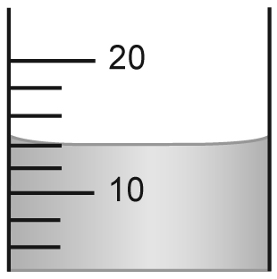
a 14 mL
b 15 mL
c 16 mL
d 18 mL
Give a reason for your answer.
__________________________________________________________________
__________________________________________________________________
(I 3.2)
11 Look at the diagram of the scale below, and then choose the correct reading:
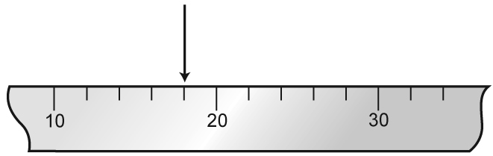
a 13
b 16
c 17.5
d 18
Give a reason for your answer.
__________________________________________________________________
__________________________________________________________________
(I 3.2)
12 How long is the block of wood shown in the diagram below?
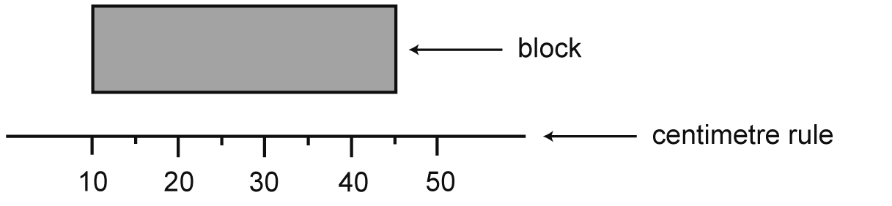
a 10 cm
b 20 cm
c 25 cm
d 35 cm
Give a reason for your answer.
__________________________________________________________________
__________________________________________________________________
(I 3.2)
13 This question refers to the following information:
1 A STRIRCLE does NOT have spikes.
2 A SQUOT has spots.
3 A STRIRCLE is round.
4 A SQUOT is NOT round.
Which of the following diagrams shows a STRIRCLE first (on the left) and a SQUOT (on the right)?
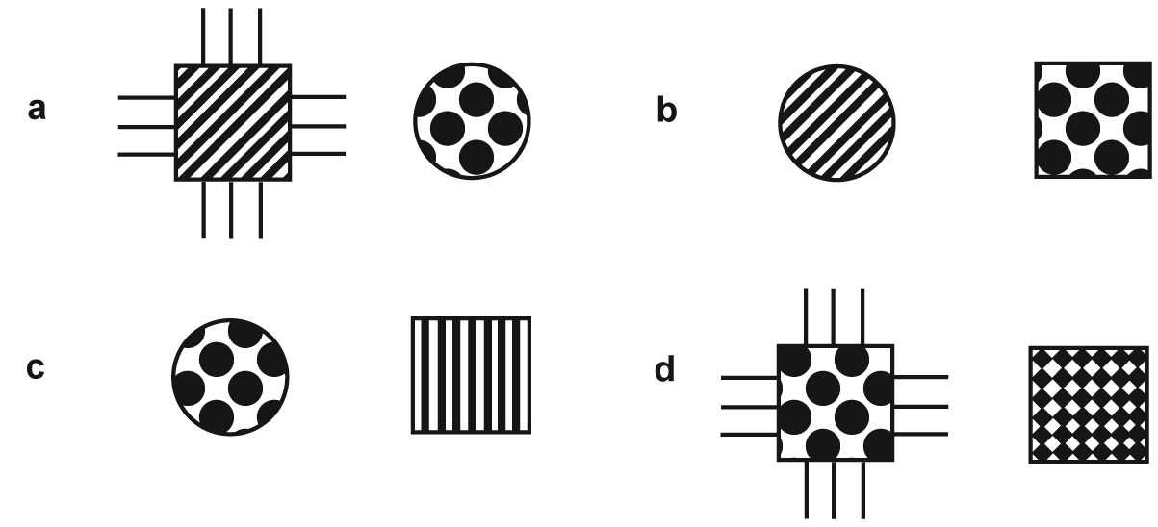
Which other diagrams have strircles?
__________________________________________________________________
__________________________________________________________________
(I 3.2)
14 The following key is for six groups of bacteria.
1a Round shape..............................................…….. go to 2
1b Not round shape.................................................. go to 3
2a With hairs............................................................ TYPE ‘A’
2b No hairs............................................................... TYPE ‘B’
3a Rod shape................................................……… go to 4
3b Spiral shape......................................................... TYPE ‘C’
4a Many hairs covering whole body..........……….. go to 5
4b Two hairs at only one end of body...................... TYPE ‘D’
5a Can form spores........................................…….. TYPE ‘E’
5b Does not form spores..................................…… TYPE ‘F’
Using this key, what are two features of TYPE ‘F’ bacteria?
a They are a rod shape and covered in hairs.
b They are a spiral shape without hairs.
c They are a spiral or rod shape and cannot form spores.
d They are round and cannot form spores.
Write down the letters of your choices to get to TYPE F bacteria.
__________________________________________________________________
__________________________________________________________________
(I 3.2)
15 Use the key in question 14 to classify the following type of bacteria.
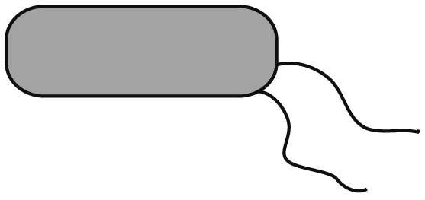
a TYPE ‘A’
b TYPE ‘B’
c TYPE ‘C’
d TYPE ‘D’
Give a reason for your answer.
__________________________________________________________________
__________________________________________________________________
(I 3.2)
PART 2
1 Consider the key below which helps identify each of the objects shown below. The creatures are called DILLS. Some are black, the others are white. Some have tails.
1a black colour go to 2
1b white colour go to 3
2a tail Dill wrigglerball
2b no tail Dill stillcube
3a tail Dill jigglercube
3b no tail go to 4
4a square shape Dill stillmegabox
4b circle shape Dill stillball
Give each of the following their correct name.
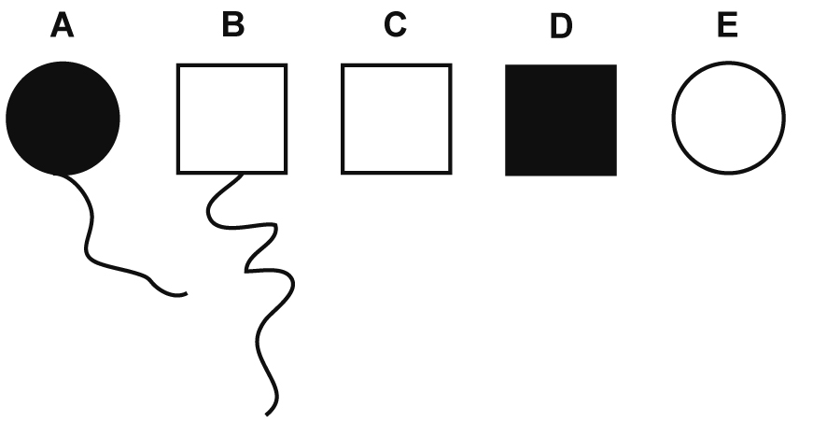
(I 4/LL 4)
2 A student did an experiment in which she heated a liquid in a conical flask. She used a retort stand, clamp, boss head and Bunsen burner. Draw a LABELLED diagram to show this equipment set-up.
(I 3.2)
3 The diagram below shows some pieces of laboratory glassware. Write the LETTER of each piece on your ANSWER sheet, then write the NAME of each piece next to its letter on your answer sheet.
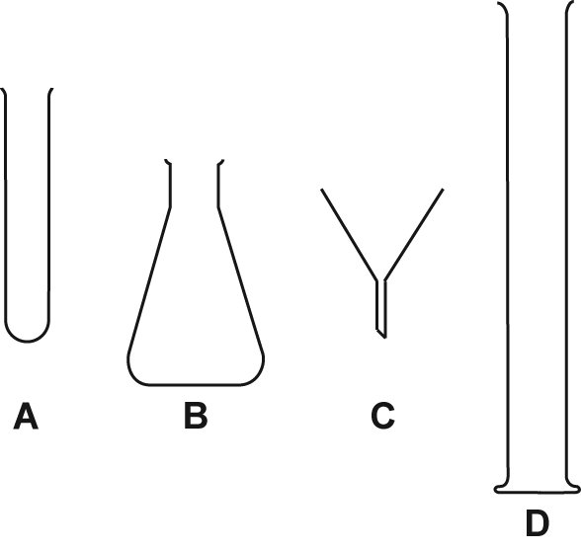
(I 3.2)
Level guide for teacher use
PART 1
Question number | Answer | Reason/written answer
1 | a | Diagrams done as vertical transverse section—quicker and simpler.
2 | b | You can’t see properly and wiping your eyes is not as effective as washing them.
3 | c | Beaker sits on wire mat on tripod.
4 | b | Never put solids in the sink and liquids in the bin are messy.
5 | c | Any other way is unsafe.
6 | b | Smelling a gas.
7 | d | Milli means one-thousandth.
8 | a | It is for holding liquids.
9 | d | 100/1000 = 0.1 L
10 | a | Read it at the bottom of the curved surface (meniscus).
11 | d | Each division is 2.
12 | d | 45 – 10 = 35
13 | b | a and c
14 | a | 1b, 3a, 4a, 5b
15 | d | Choices were 1b, 3a, 4b.
PART 2
1 (I 4/LL 4)
A = Dill wrigglerball, B = Dill jigglercube, C = Dill stillmegabox, D = Dill stillcube, E = Dill stillball
2 Student may draw a two-dimensional version of the following diagram using scientific representations of equipment. (I 3.2)
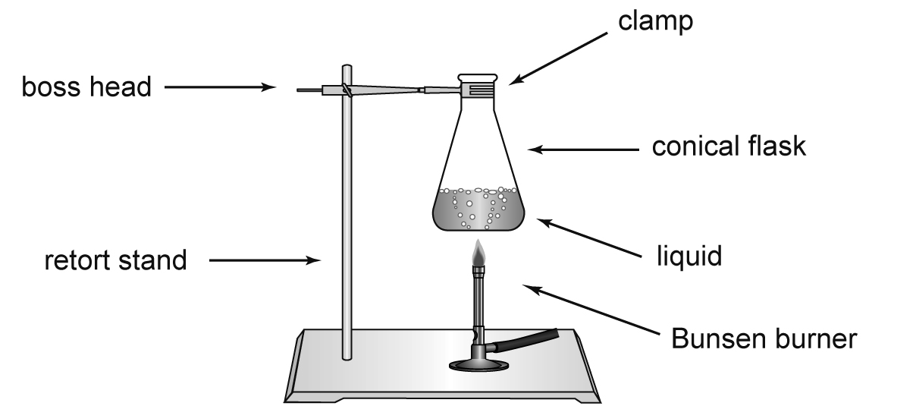
3 (I 3.2)
A = test tube, B = conical flask, C = filter funnel, D = measuring cylinder

